Ans)2) “Systeminfo”

Ans)3) Ping google.com

Ans)4) ipconfig

Ans)7) 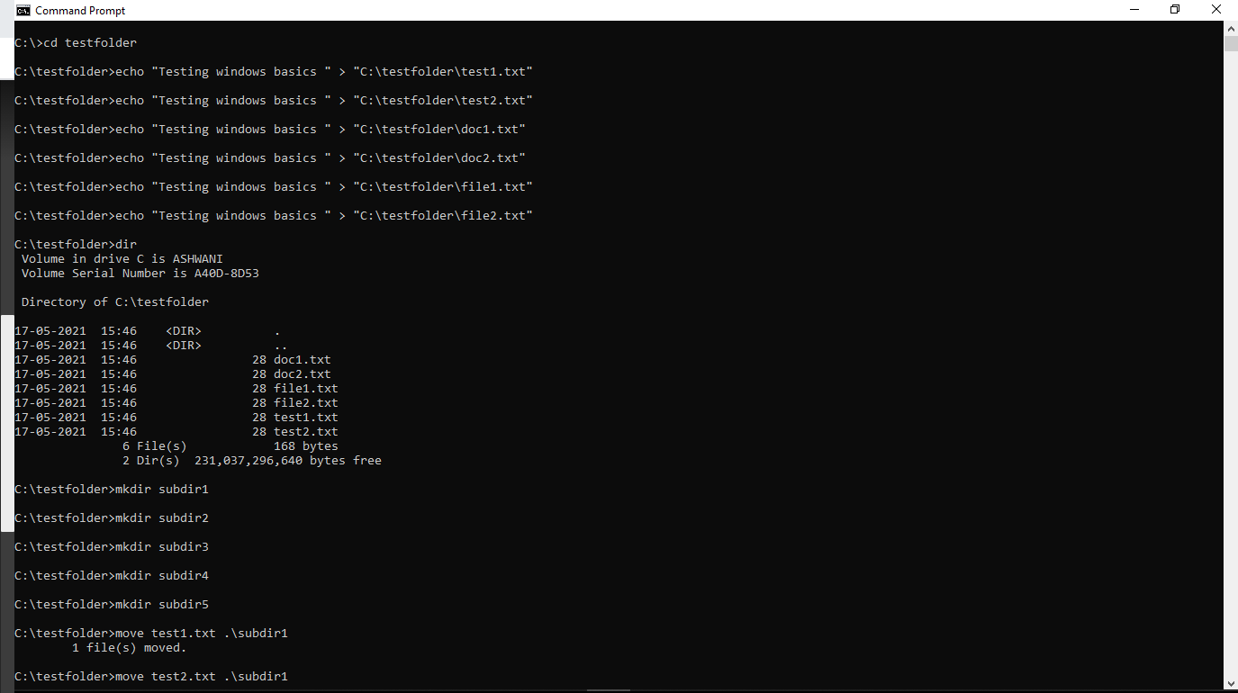

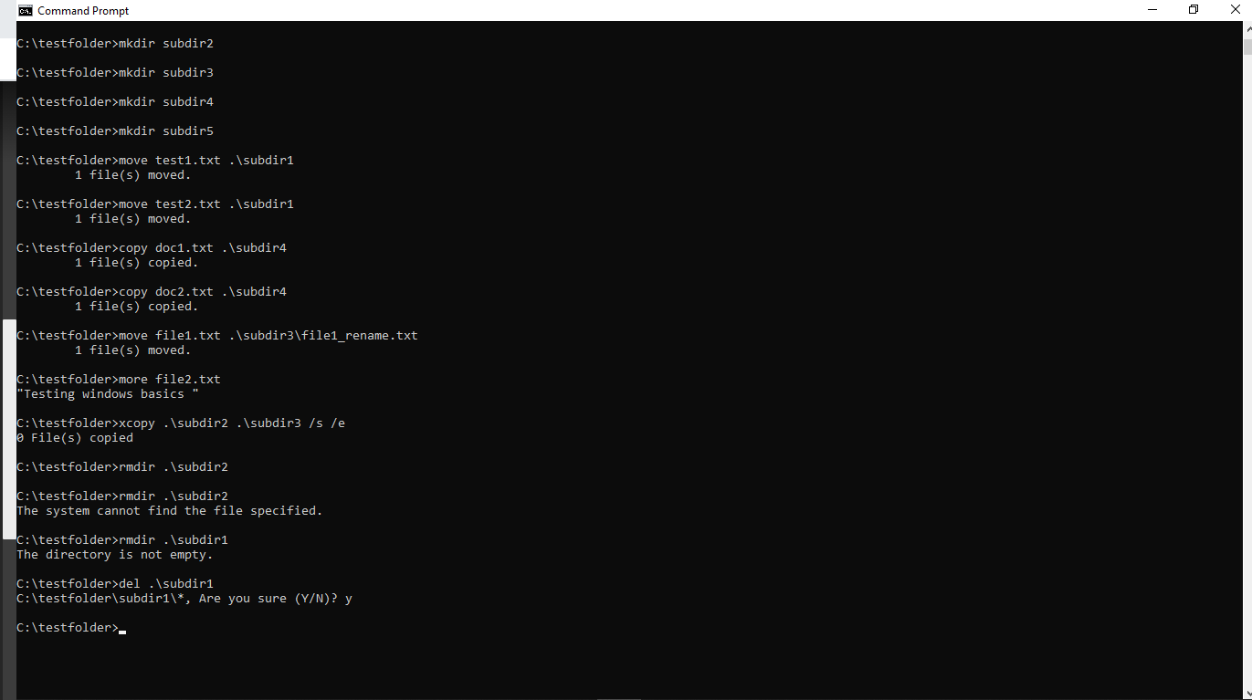

Ans)8) 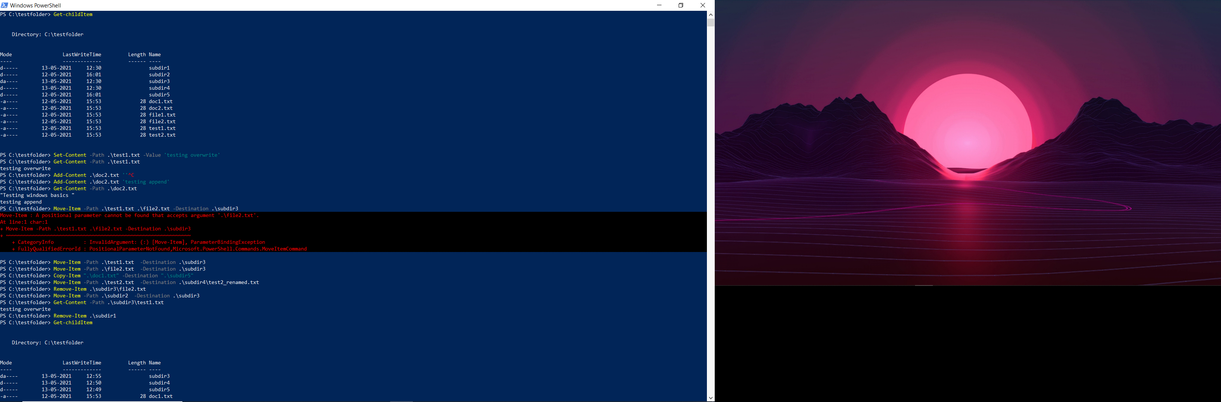

Ans)9) C:\WINDOWS\system32>reg add HKLM\Software /v my_testkey  
The operation completed successfully.  
C:\WINDOWS\system32>reg add HKLM\Software /v my_testValue /t REG_DWORD /d 0  
The operation completed successfully.C:\WINDOWS\system32>reg query HKLM\SoftwareHKEY_LOCAL_MACHINE\Software  
   (Default)   REG_SZ  
   my_testkey   REG_SZ  
   my_testVal   REG_SZ  
   my_testValue    REG_DWORD   0x0HKEY_LOCAL_MACHINE\Software\AMD  
HKEY_LOCAL_MACHINE\Software\Android Studio  
HKEY_LOCAL_MACHINE\Software\ASIO  
HKEY_LOCAL_MACHINE\Software\Atheros  
HKEY_LOCAL_MACHINE\Software\ATI Technologies  
HKEY_LOCAL_MACHINE\Software\Autodesk  
HKEY_LOCAL_MACHINE\Software\Classes  
HKEY_LOCAL_MACHINE\Software\Clients  
HKEY_LOCAL_MACHINE\Software\Creative Tech  
HKEY_LOCAL_MACHINE\Software\CVSM  
HKEY_LOCAL_MACHINE\Software\DefaultUserEnvironment  
HKEY_LOCAL_MACHINE\Software\DELL  
HKEY_LOCAL_MACHINE\Software\Dell Computer Corporation  
HKEY_LOCAL_MACHINE\Software\Dell Inc.  
HKEY_LOCAL_MACHINE\Software\Google  
HKEY_LOCAL_MACHINE\Software\InstalledOptions  
HKEY_LOCAL_MACHINE\Software\Intel  
HKEY_LOCAL_MACHINE\Software\JavaSoft  
HKEY_LOCAL_MACHINE\Software\JreMetrics  
HKEY_LOCAL_MACHINE\Software\Khronos  
HKEY_LOCAL_MACHINE\Software\Macromedia  
HKEY_LOCAL_MACHINE\Software\Macrovision  
HKEY_LOCAL_MACHINE\Software\McAfee  
HKEY_LOCAL_MACHINE\Software\[McAfee.com](http://mcafee.com/)  
HKEY_LOCAL_MACHINE\Software\McAfee.logging  
HKEY_LOCAL_MACHINE\Software\Microsoft  
HKEY_LOCAL_MACHINE\Software\Mozilla  
HKEY_LOCAL_MACHINE\Software\MozillaPlugins  
HKEY_LOCAL_MACHINE\Software\Node.js  
HKEY_LOCAL_MACHINE\Software\Nuance  
HKEY_LOCAL_MACHINE\Software\ODBC  
HKEY_LOCAL_MACHINE\Software\OEM  
HKEY_LOCAL_MACHINE\Software\OpenSSH  
HKEY_LOCAL_MACHINE\Software\OpenVPN  
HKEY_LOCAL_MACHINE\Software\Oracle  
HKEY_LOCAL_MACHINE\Software\Partner  
HKEY_LOCAL_MACHINE\Software\PC-Doctor  
HKEY_LOCAL_MACHINE\Software\Policies  
HKEY_LOCAL_MACHINE\Software\Python  
HKEY_LOCAL_MACHINE\Software\Realtek  
HKEY_LOCAL_MACHINE\Software\RegisteredApplications  
HKEY_LOCAL_MACHINE\Software\RivetNetworks  
HKEY_LOCAL_MACHINE\Software\SRS Labs  
HKEY_LOCAL_MACHINE\Software\Synaptics  
HKEY_LOCAL_MACHINE\Software\TAP-Windows  
HKEY_LOCAL_MACHINE\Software\Waves Audio  
HKEY_LOCAL_MACHINE\Software\WebDiscoverBrowser  
HKEY_LOCAL_MACHINE\Software\Windows  
HKEY_LOCAL_MACHINE\Software\WOW6432Node  
HKEY_LOCAL_MACHINE\Software\xamppC:\WINDOWS\system32>reg add HKLM\Software /v my_testValue /t REG_DWORD /d 1  
Value my_testValue exists, overwrite(Yes/No)? Y  
The operation completed successfully.  
C:\WINDOWS\system32>reg query HKLM\SoftwareHKEY_LOCAL_MACHINE\Software  
   (Default)   REG_SZ  
   my_testkey   REG_SZ  
   my_testVal   REG_SZ  
   my_testValue   REG_DWORD   0x1HKEY_LOCAL_MACHINE\Software\AMD  
HKEY_LOCAL_MACHINE\Software\Android Studio  
HKEY_LOCAL_MACHINE\Software\ASIO  
HKEY_LOCAL_MACHINE\Software\Atheros  
HKEY_LOCAL_MACHINE\Software\ATI Technologies  
HKEY_LOCAL_MACHINE\Software\Autodesk  
HKEY_LOCAL_MACHINE\Software\Classes  
HKEY_LOCAL_MACHINE\Software\Clients  
HKEY_LOCAL_MACHINE\Software\Creative Tech  
HKEY_LOCAL_MACHINE\Software\CVSM  
HKEY_LOCAL_MACHINE\Software\DefaultUserEnvironment  
HKEY_LOCAL_MACHINE\Software\DELL  
HKEY_LOCAL_MACHINE\Software\Dell Computer Corporation  
HKEY_LOCAL_MACHINE\Software\Dell Inc.  
HKEY_LOCAL_MACHINE\Software\Google  
HKEY_LOCAL_MACHINE\Software\InstalledOptions  
HKEY_LOCAL_MACHINE\Software\Intel  
HKEY_LOCAL_MACHINE\Software\JavaSoft  
HKEY_LOCAL_MACHINE\Software\JreMetrics  
HKEY_LOCAL_MACHINE\Software\Khronos  
HKEY_LOCAL_MACHINE\Software\Macromedia  
HKEY_LOCAL_MACHINE\Software\Macrovision  
HKEY_LOCAL_MACHINE\Software\McAfee  
HKEY_LOCAL_MACHINE\Software\[McAfee.com](http://mcafee.com/)  
HKEY_LOCAL_MACHINE\Software\McAfee.logging  
HKEY_LOCAL_MACHINE\Software\Microsoft  
HKEY_LOCAL_MACHINE\Software\Mozilla  
HKEY_LOCAL_MACHINE\Software\MozillaPlugins  
HKEY_LOCAL_MACHINE\Software\Node.js  
HKEY_LOCAL_MACHINE\Software\Nuance  
HKEY_LOCAL_MACHINE\Software\ODBC  
HKEY_LOCAL_MACHINE\Software\OEM  
HKEY_LOCAL_MACHINE\Software\OpenSSH  
HKEY_LOCAL_MACHINE\Software\OpenVPN  
HKEY_LOCAL_MACHINE\Software\Oracle  
HKEY_LOCAL_MACHINE\Software\Partner  
HKEY_LOCAL_MACHINE\Software\PC-Doctor  
HKEY_LOCAL_MACHINE\Software\Policies  
HKEY_LOCAL_MACHINE\Software\Python  
HKEY_LOCAL_MACHINE\Software\Realtek  
HKEY_LOCAL_MACHINE\Software\RegisteredApplications  
HKEY_LOCAL_MACHINE\Software\RivetNetworks  
HKEY_LOCAL_MACHINE\Software\SRS Labs  
HKEY_LOCAL_MACHINE\Software\Synaptics  
HKEY_LOCAL_MACHINE\Software\TAP-Windows  
HKEY_LOCAL_MACHINE\Software\Waves Audio  
HKEY_LOCAL_MACHINE\Software\WebDiscoverBrowser  
HKEY_LOCAL_MACHINE\Software\Windows  
HKEY_LOCAL_MACHINE\Software\WOW6432Node  
HKEY_LOCAL_MACHINE\Software\xamppC:\WINDOWS\system32>reg delete HKLM\Software /v my_testvalue  
Delete the registry value my_testvalue (Yes/No)? Y  
The operation completed successfully.C:\WINDOWS\system32>reg delete HKLM\Software  
Permanently delete the registry key HKEY_LOCAL_MACHINE\Software (Yes/No)? Y  
The operation completed successfully.

Ans)10) 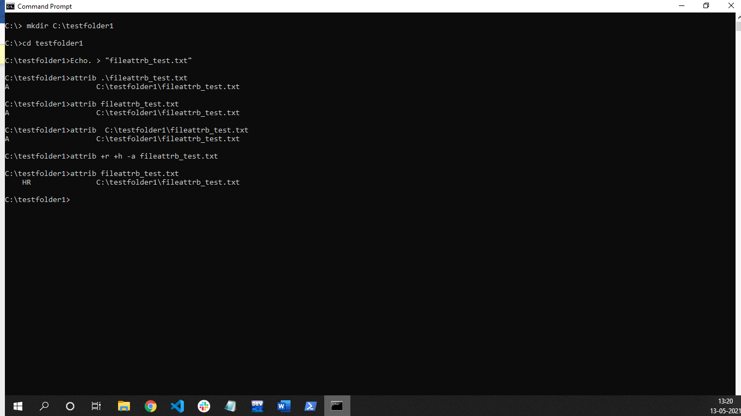

Ans)11) 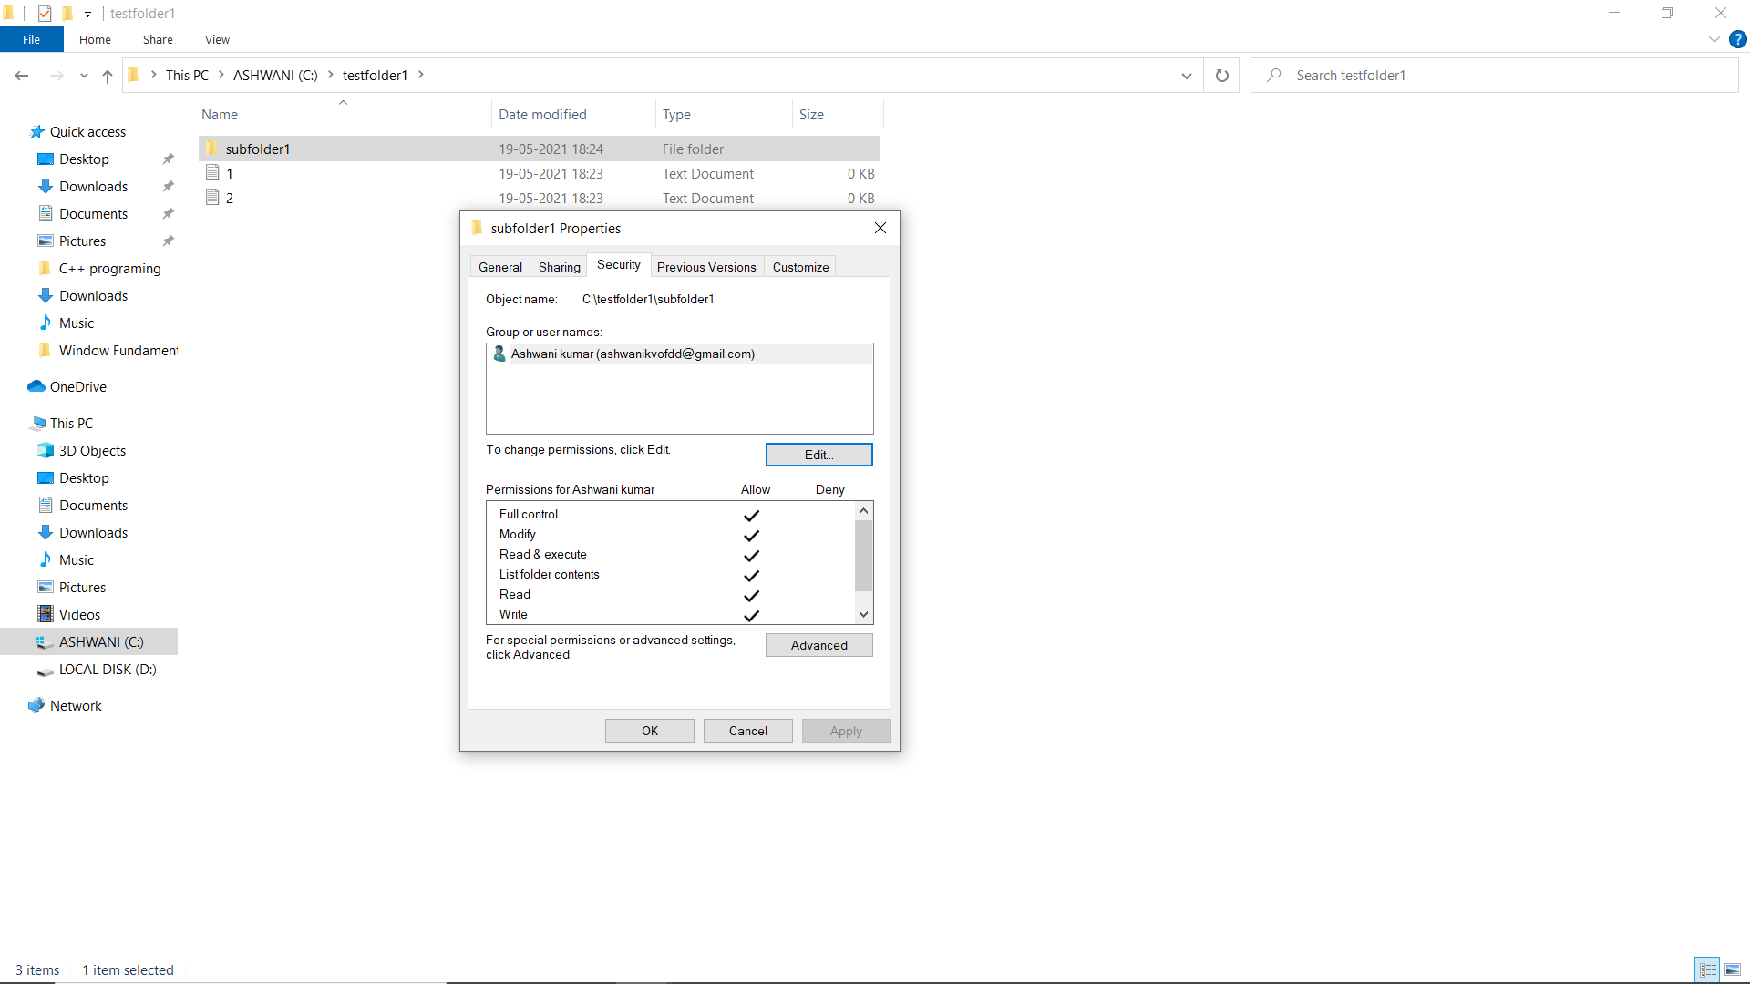

Ans)12) 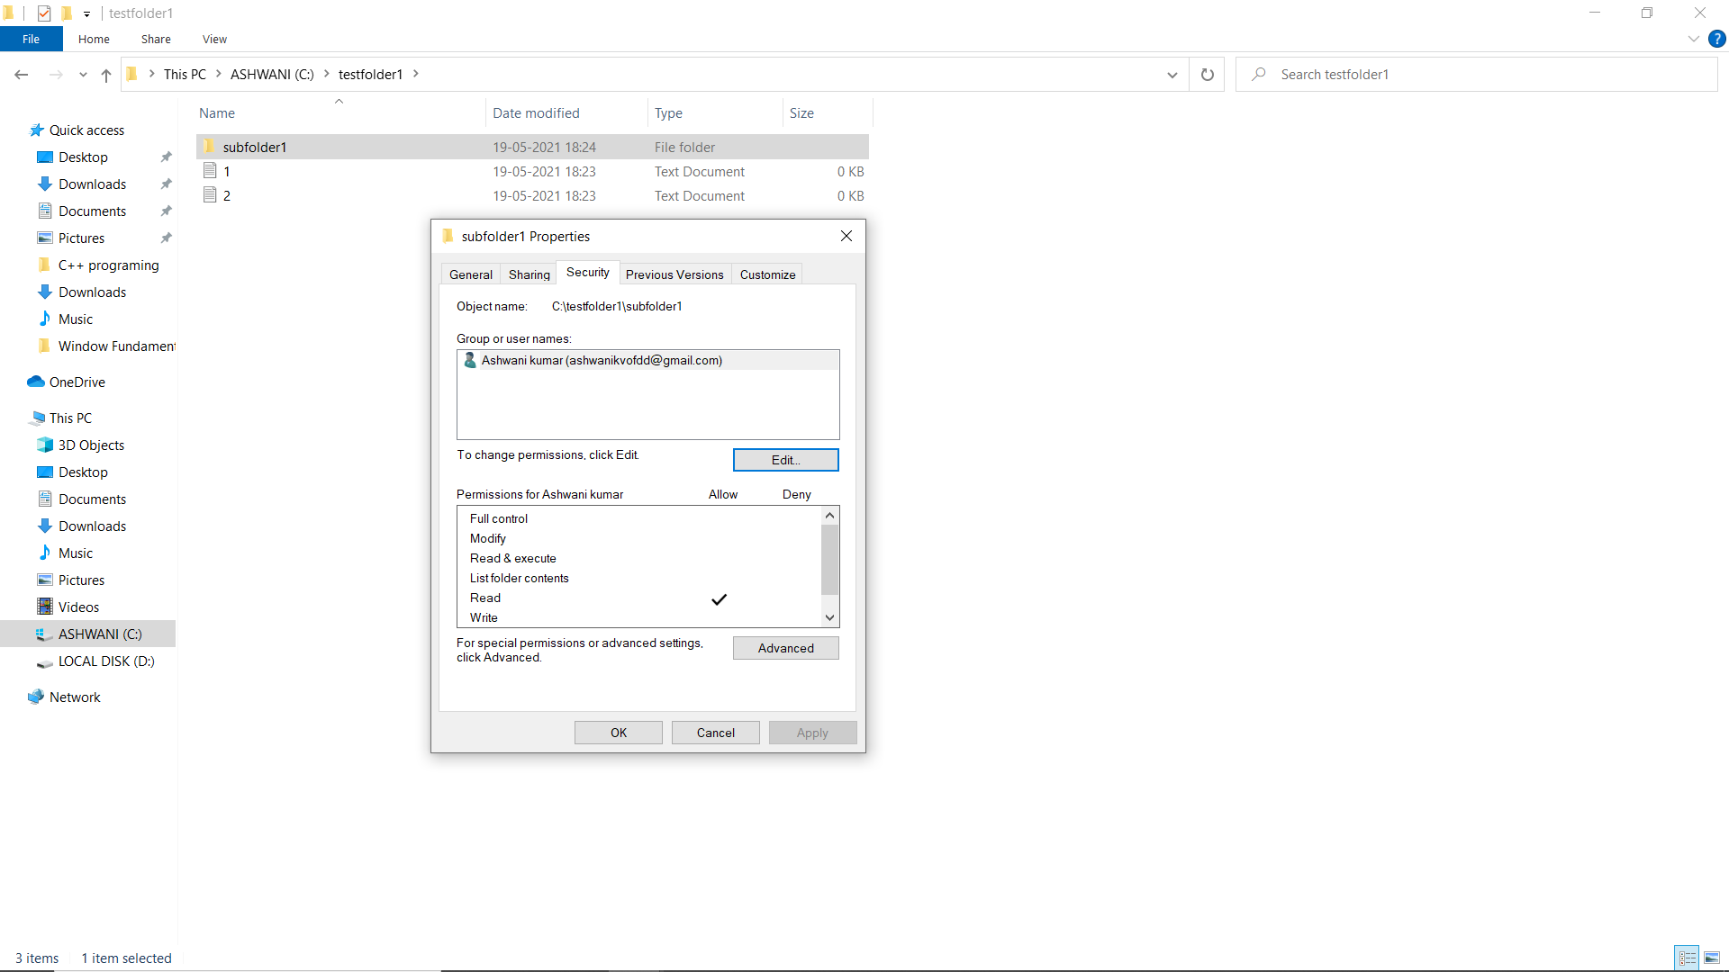

Ans)14) 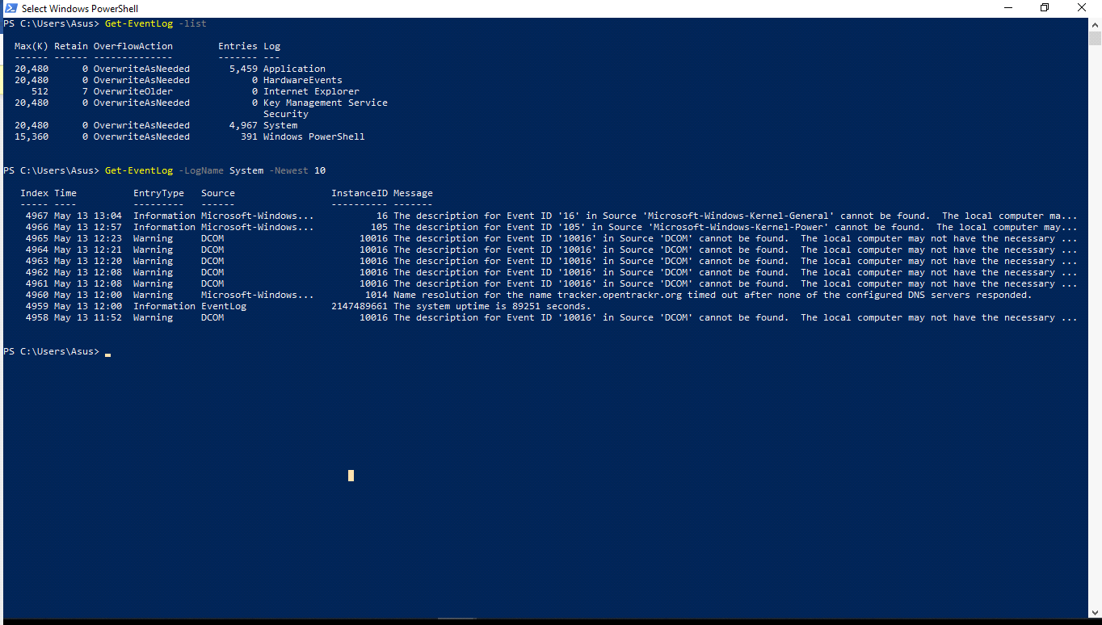

Ans)16)

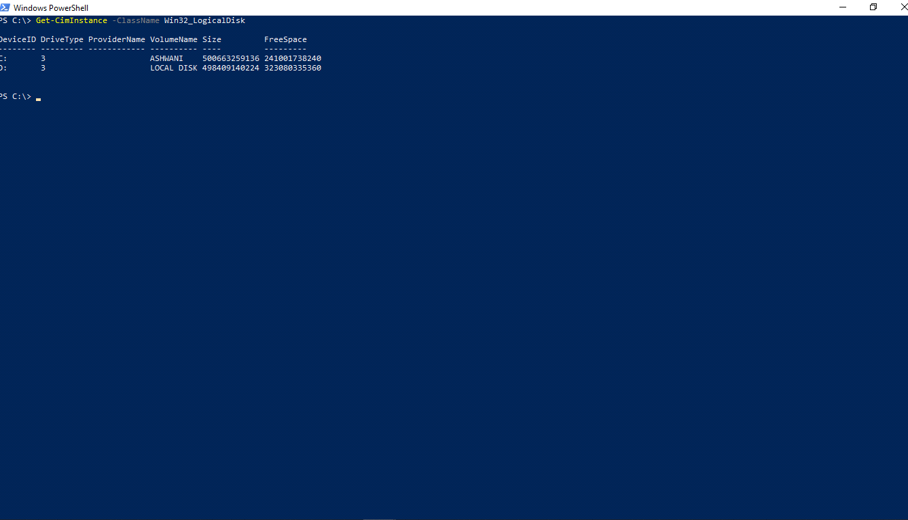

Ans)19) 